**Smart Management Of Street Lights For Energy Conservation**

**Aim:**

This paper aims to conduct research on the street lighting system in order to introduce an effective street lighting system that can significantly reduce energy consumption. Nowadays, street lights consume a large portion of the overall energy, including the energy efficiency. Because of the importance of street lighting to improve a person's quality of life, there are many street light systems in use around the world. The main function of the street lighting system is to illuminate the streets during the dark and illuminate them in the dark. Many countries use conventional street lighting and off street lighting based on incandescent light and usually use more energy-efficient fluorescent lamps. This study proposes a light lighting system that uses the latest savings technology Lighting Emitting Diode (LED) and a sensor network operated by a microcontroller. A comparison between the proposed system and the standard street lighting system is presented in terms of energy consumption. The Proteus environment is used to build system integration with the microcontroller. Based on the results obtained from the proposed smart lighting system, it is evident that power consumption is greatly reduced.

**Hardware & Software Requirements:**

1. Arduino Nano
2. Street light
3. Relay
4. IR sensor
5. Zigbee trans receiver
6. Arduino Uno R3

**Project Flow:**

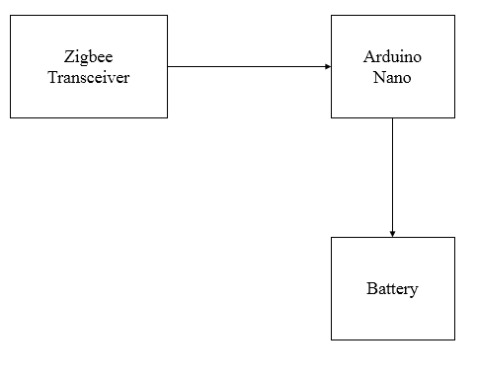

**Schematic Diagram Of Transmitter**

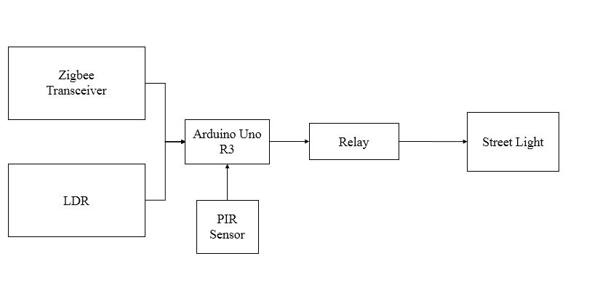

**Schematic Diagram Of Receiver**

**Proposed System:**

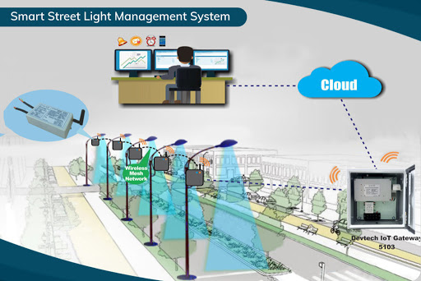

**Stake Holders:**

The main stakeholders the local authorities who are in charge of fixing these Lights. As they need the most in order to save the electricity and also reduce the usage of electricity.

The next main stake holders are both sector i.e. private sector and govt. Sector. As govt’s duty is to provide the min. facilities to its people within min. budget and pvt. Sectors like shopping malls, hospitals and many multi stored building’s needs such lightning’s in order to save the power and money.

Finally the researchers on the other side would try to make it more feasible and more affordable so that it would be useful to everyone and add specific features for the future generations.